Decision Support and Business Intelligence  
  
 ALY6060 - Spring 2020

**Analytics Assignment**

SUBMITTED BY:  Jie Wang

SUBMITTED TO PROFESSOR: Vera Yanovsky

DATE: 05-03-2020

**Question1**

From the screenshots, we can know the value of R squared, then top two covariates are rating and limit which represent third party credit score ratings and customers’ credit card account limits respectively.

**Question2:**

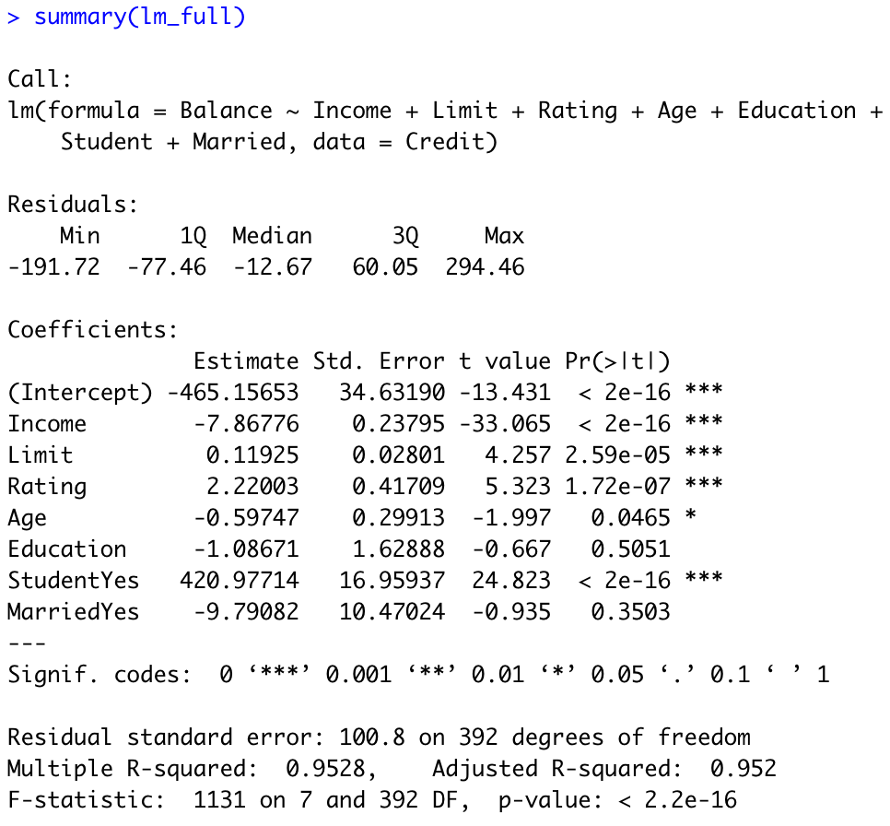

In the full model, the smaller p value of the covariate the more significant for the model. Therefore, from the screenshots, we can know that income, limit, rating and the status of student have significant association with the full model. In addition, from the correlation of the covariates with balance, we can know income, rating and limit are important. Moreover, from the simple linear models, we can know that income, limit, rating and the status of student are important, so they are the same covariates in both simple linear models and the full model.

**Question3**

I think the information of credit from the third party is very important because the correlation between the credit rating and balance is very big. It means that the credit rating is a very meaningful value towards balance. From the graph, we can know that people have higher credit rating tend to have higher balance. In addition, the bank wants to attract and predict new customers who have the potential to have larger balances in their account, so they can obtain the conclusion by assessing the credit rating. The credit rating scores applied by the third party is a valuable information to the bank.